Mandatory Disclosure as per AICTENorms

Mandatory Disclosure
1 | AICTE File No. | Western/1-43656742068/2024/EOA
 | Date & Period of last approval | March 2024 to April 2025
2 | Name of the Institution | ACHARYA SHRIMANNARAYAN POLYTECHNIC  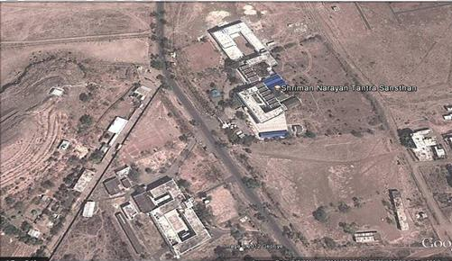
 | Address of the Institution | ARVI ROAD  PIPRI (Meghe), WARDHA
 | City & Pin Code | WARDHA, 442001
 | State / UT | MAHARASHTRA
 | Longitude &  Latitude | LATITUDE --20.77686 LONGITUDE-78.593659
 | Phone number with STD code | Code 07152-230519
 | Office hours at the Institution | 09:00 AM to 06:00 PM
 | Academic hours at the Institution | 10:00 AM to 05:30 PM
 | Email | astsw@rediffmail.com
 | Website | https://asp.shikshamandal.org/
 | Nearest Railway  Station (dist in Km) | WARDHA @ 5 km
 | Nearest Airport (Dist in Km) | Dr. BABASAHEB AMBEDKAR INTERNATIONAL AIRPORT, NAGPUR @ 75  km
3 | Type of Institution | GOVT. AIDED
 | Category (1) of the  Institution | MINORITY
 | Category (2) of the  Institution | Co-Ed
4 | Name of the  Organization | SHIKSHA MANDAL, WARDHA.

 | running the Institution
 | Type of the organization | Trust
 | Address of the  organization | JAMANALAL BAJAJ MARG, CIVIL LINES, WARDHA 442001
 | Registered with Registration date | Registered under section XXI of societies registration act 1860 & under section XXIX of Bombay Public Trust Act 1950  28/12/1952
 | Website of the organization | www.shikshamandal.org
5 | Name of  Affiliation Board | Maharashtra State Board of Technical Education, Mumbai
 | Address | GOVT. POLYTECNIC BUILDING, 4TH FLOOR, 49, KHERWADI, BANDRA  (EAST), MUMBAI -400051
 | Website | www.msbte.org.in
 | Latest affiliation period | JUNE 2024
6 | Principal/Director | DR. PRAVIN SUDHAKAR PACHPOR
 | Exact Designation | PRINCIPAL
 | Email | pravinpachor@gmail.com
 | Highest Degree | Ph.D
 | Field of specialization | Mechanical Engineering
7 | Governing Board Members |  | Sr. No. | Name | Designation
 |  |  | 1 | Shri Shekharji Bajaj  President, Shiksha Mandal, Wardha | President
 |  |  | 2 | Shri Sanjay Bhargava  Chairman, Shiksha Mandal, Wardha | Chairman
 |  |  | 3 | Dr. Wasudha Wanmali  Deputy Secretary, Shiksha Mandal, Wardha | Member
 |  |  | 4 | Shri Ambikaprasad Tiwari  Member, Shiksha Mandal, Wardha | Member
 |  |  | 5 | Shri C. D. Zawar  Member, Shiksha Mandal, Wardha | Member
 |  |  | 6 | Secretary, Maharashtra State Board of Technical Education, Mumbai. | Member
 |  |  | 7 | Director, Directorate of Technical Education, Maharashtra State, Mumbai | Member
 |  |  | 8 | Shri C.Y.Deshpande,  Dean (Bajaj Institute of Technology), Wardha | Special Invitee
 |  |  | 9 | Shri Bhupendra Lohiya,  Shiksha Mandal, Wardha. | Special Invitee
 |  |  | 10 | The Principal,  Bajaj Institute of Technology, Wardha | Special Invitee
 |  |  | 11 | Dr. P.S.Pachpor,  Principal, Acharya Shrimannarayan Polytechnic, Pipri, Wardha. | Member Secretary

8 | Academic Advisory Body | Dr. P.S.PACHPOR Ph.D. (Mech. Engg.) PRINCIPAL PRESIDENT  Mr. C. Y. DESHPANDE, B.E. (Mechanical Engg.) Rtd.G.M. (R&D- Mechanical Engg.-Bajaj Auto. DEAN, BAJAJ INSTITUTE OF TECHNOLOGY, WARDHA SPECIAL INVITEE  Dr. P.B. WAGHMARE Ph.D. (Civil Engg.) I/C H.O.D. (Civil Engg.) MEMBER  Mr. R.M.Kasare M.Tech (Mechanical Engg.) I/C H.O.D. (Mechanical Engg.) MEMBER
 | Frequency of meeting & last Date of meeting | Twice in a Year.  Last meeting 7th Oct 2019
9 |  | ORGANIZATIONAL STRUCTURE & CHART FOR DAY-TO-DAY  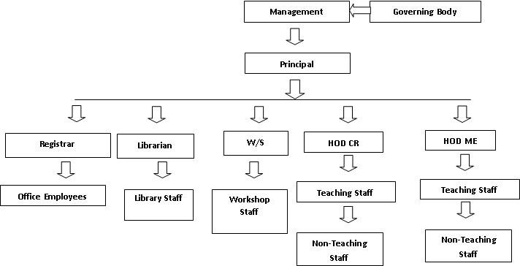
10 | Student feedback mechanism on  Institutional Governance/Facult y performance | - Every Semester the feedback from students with regard to the faculty performance is collected. The suggestions for improvement in performance are communicated to the faculty members. Senior faculty helps the junior faculty in overcoming the difficulties and help in implementing the suggestions indicated based on student feedback.  - Every faculty member will submit staff self-appraisal by the end of every semester to the concerned departmental HODs. HOD will forward the same  to the Principal with his remarks.
11 | Grievance redressal  mechanism for faculty, staff and  students | - The Grievance Redressal committee comprising of class representatives,  - Departmental HODs, Student Welfare Officer and Principal handle Student grievances.  - An Anti-Ragging Committee involving the Principal, HOD’s, faculty members, etc.
12 | Name of the Department* | Department of Civil & Rural Engg.  Department of Mechanical Engg.
13 | Course | Diploma in CIVIL & RURAL ENGG.  Diploma in MECHANICAL ENGG.
14 | Level | Diploma
 | 1st Year of approval by the Council
 |  |  | CIVIL & RURAL ENGINEERING (Intake – 60) | 1963
 |  |  | MECHANICAL ENGINEERING (Intake – 60) | 1994

